***Southwest***

***Software***

 ***Development***

***Team***

**Second Year Computing Project**

**2011/2012**

**Fully Automated Payroll System**

**User Manual Design**

**Design & Development Team:**

**James Madden: X00086390:**

**Project Manager, Customer Liaison, Software and Database Development, System Testing & Quality Control.**

**Shane Murphy: X00085315:**

**System Design, Software and Database Development, System Testing & Quality Control.**

**Maciej Macierzynski: X00086366:**

**System Design, Software and Database Development, System Testing & Quality Control.**

Contents

Installation 3

Company Setup 3

System Log In 3

Login Errors 4

Incorrect Username 4

Incorrect Password 4

No details Entered 4

Customer Details 5

Adding Employee’s 7

Updating Employee Details 8

Ceasing Employment 10

Updating Employee Revenue Details 11

Timesheets 11

Payslips 11

Payroll Report 11

Revenue Reports 12

Form P30 12

Form P35 12

Form P60 12

Form P45 14

Glossary 14

# Installation

This section shall provide a detailed description of the installation process.

# Company Setup

This section shall provide a detailed description of the company setup procedure. Setup Username/Password

# System Log In

Upon launching the application, the user is presented with a login screen. To continue farther into the application, a valid username and password must be entered. Each input text field is labeled ‘Username’ and ‘Password’ for each respective input required. The ‘Cancel’ button allows the user to close the application at any time. Once valid details are entered, the ‘OK’ button can be clicked to advance to the next screen. The system affords the user 3 attempts to complete the login process, if the user fails to enter a valid username and password after 3 attempts, the system exits.

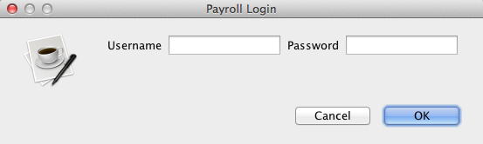

## Login Errors

In the event that a user incorrectly enters wrong login details, an error message will be displayed. The error is tailored to whichever text field was invalid, prompting the user to rethink their input.

### Incorrect Username

The following screen is displayed if the username does not match those stored in the database.

**(SCREENSHOT)**

### Incorrect Password

The following screen is displayed if the users password does not match those found in the database or associated with the username entered.

**(SCREENSHOT)**

### No details Entered

If the user leaves both the username and password fields empty, the following message is displayed to the user.

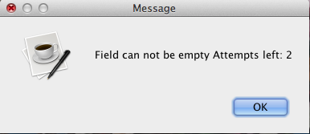

# Customer Details

After the system accepts the username and password, the user is presented with the Employee Details screen. This is the first page the user sees of the application; from here the user can navigate through the application using the tabbed screens.

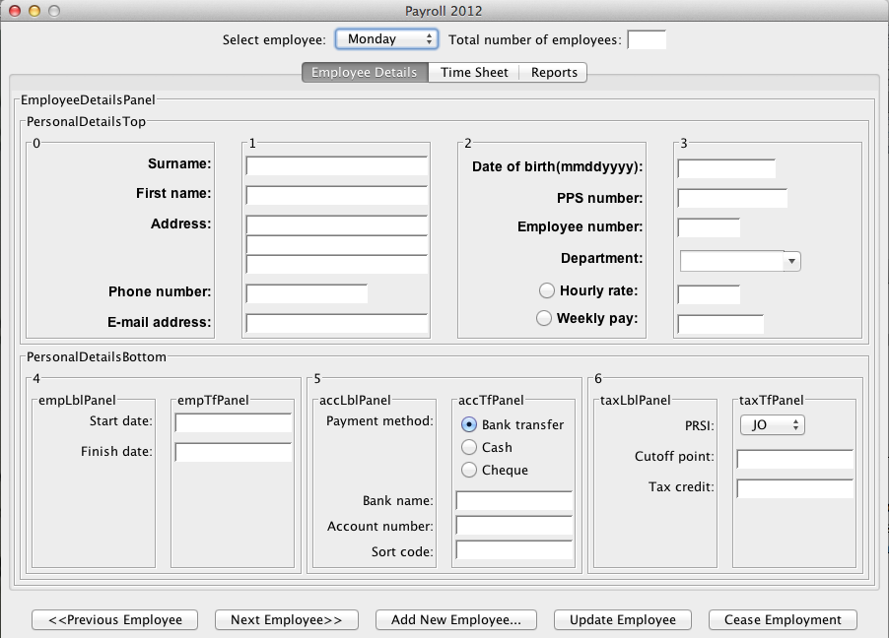

From the employee details screen one can add a new employee, update a current employee or cease their employment. The main function of this page is to provide access to employee details or to update/create employees. An individual employee can be selected from a combo box at the top of the screen.

Details available for display or submition on this screen are as follows:

|  |  |
| --- | --- |
| Surname | Employees Surname(s) |
| First name | Employees First Name(s). |
| Address | Employees current place of residence |
| Phone Number | Contact telephone number for the Employee |
| E-mail | Employees E-mail address |
| Date of Birth | Employees Date of Birth |
| PPSN | Employees Personal Public Service Number |
| Employee ID | Unique ID number assigned by the system to each employee |
| Department | Department to which the employee is assigned |
| Hourly rate/Weekly rate | Employee can either be paid per hour or receive an annual salary. Only one may be selected |
| Employment start date | Date employee started employment |
| Employment end date (if applicable) | Date employee ceased employment |
| Payment method | Method by which wages are paid to the employee, only one selectable |
| Bank name | Name of employees bank. |
| Account Number | Account number of the employees current account |
| Sort code | Sort code for the customers branch |
| PRSI | Employees Pay Related Social Insurance contribution. |
| Tax cutoff point | Employee’s annual tax cutoff point. |
| Tax Credits | Employees annual tax credits. |

# Adding Employee’s

Clicking “Add New Employee.” will show a Dialog box where the user must enter in the mandatory fields required to create an employee. The following fields are mandatory and must contain a valid value to create a new employee:

* First Name
* Surname
* PPSN
* Employee Type

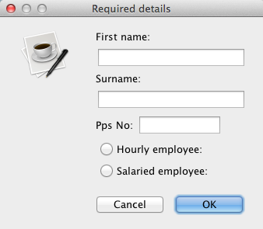

Once the OK button is clicked, a new row in the database is created with these details and all other non-mandatory fields are set to Null. Timesheets and Reports can now be created for the employee. This row is a permanent addition, and when the employee’s time with the company ends, any irrelevant details are cascaded to null, as described in the “Cease Employment section. To add additional details to the employee, the employee may be updated, as described in the next section.

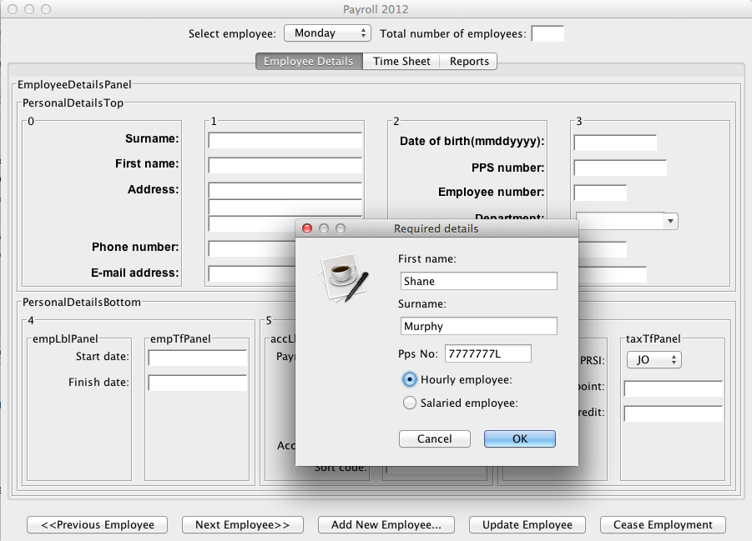

**(SCREENSHOT)**

# Updating Employee Details

To update an employee’s details, first the employee to be updated must be selected from the ‘Select Employee’ combo box at the top of the page, if not already selected. The displayed employee details can be edited and updated to the most recent available information by filling in or editing the fields.

Fields available to be edited here are as follows:

* Surname
* First name
* Address
* Phone Number
* E-mail Address
* Date of Birth
* PPSN
* Department
* Employee Rate Type
* Employee Rate
* Payment Method
* Band Name
* Account Number
* Sort Code
* PRSI
* Cutoff Point
* Tax Credit

The following fields may not be edited:

Employee Number

* Start Date
  + Set when employee is created
* Finish Date
  + Use the Cease Employment function to set finish date

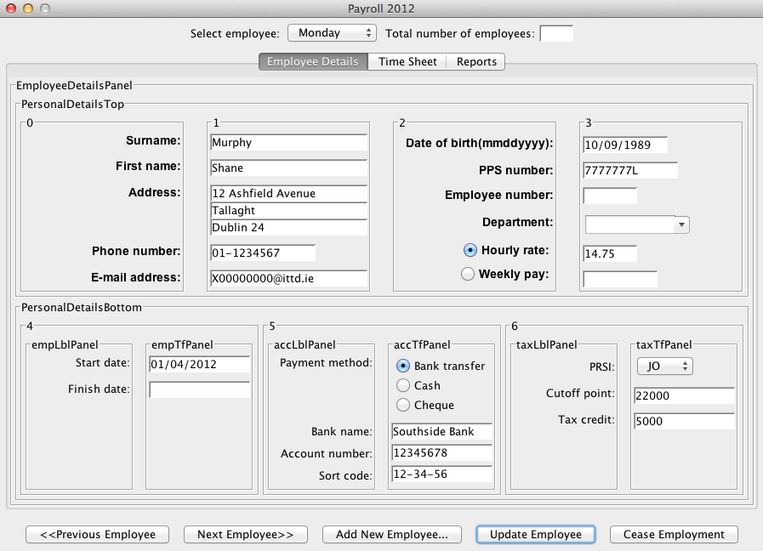

The entry for the selected employee is committed to the database upon clicking “Update Employee”.

## Ceasing Employment

To terminate a workers employment with the company, select the employee from the combo box at the top of the screen and click the “Cease Employment button”. Clicking this button presents the user with a dialog box where the termination date is entered.

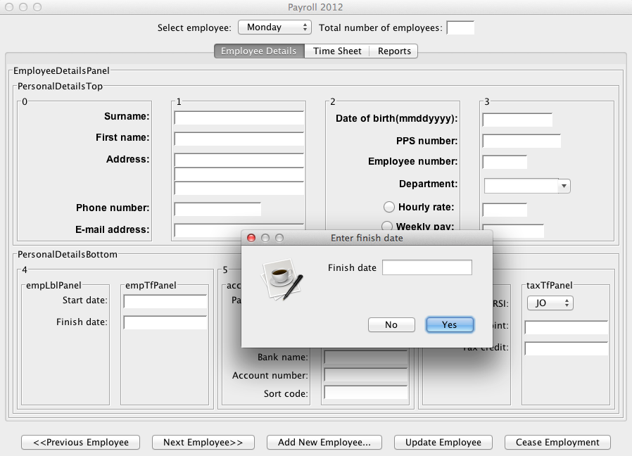

Fill in the date and press “Yes” to terminate the employee. The system will then request the user to confirm the termination before applying any changes to the database. Terminated employees may not be edited and a termination may not be undone.

## Macintosh HD:Users:shanemurphy:Dropbox:College:Semester4:Project:GUI:CeaseEmployment.png

Click “No” to abort the termination process.

# Updating Employee Revenue Details

This section shall provide a detailed description of the update employee revenue details procedure.

# Timesheets

This section shall provide a detailed description for entering timesheet details for each employee.

# Payslips

This section shall provide a detailed description printing employee payslips.

# Payroll Report

This section shall provide a detailed description for printing the weekly payroll report.

# Revenue Reports

This section shall provide a detailed description for printing the revenue reports as listed below.

## Form P30

A P30 is a bi-monthly Pay As You Earn (PAYE) and Pay Related Social Insurance (PRSI) return to the Revenue. In this form the employer declares the total amount of PAYE and PRSI deducted from his employees wages. This form is sent to the revenue along with a cheque for the liability.

## Form P35

A P35 must be submitted by each registered employer by the 15th February for the previous year ending 31st December. This form declares the total PAYE and PRSI employee deductions by the employer for the entire year. It can be accompanied with payment for the settlement of any outstanding liabilities from P30 forms throughout the year.

## Form P60

A P60 relates to an employee’s earnings, PRSI and tax deductions for the previous year. This form is issued to the employee by their employer at the end of each year. The employee is entitled to receive this form by the 15th February if employed on the 31st December.

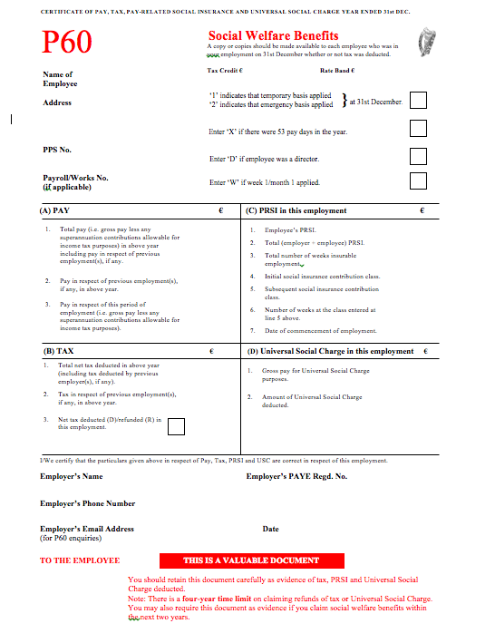

## Form P45

A P45 is a multi-part form issued upon a workers termination of their employment with their employer. It details the employee’s earnings and tax’s paid during their period of employment. Parts of this form are issued to the Revenue, retained by the employer and Part 3 is issued to the terminated employee. This form is issued to a new employer to ensure correct tax rates upon commencing new employment. If this form has been lost, the employee may be placed on “Emergency Tax” until tax rates are determined or a P46 filed and returned to the employer.

# Glossary

An online version of this document shall be developed in HTML and posted online.